Multiple-choice section

|  |  |  |  |  |  |  |  |  |  |
| --- | --- | --- | --- | --- | --- | --- | --- | --- | --- |
| Question | 1 | 2 | 3 | 4 | 5 | 6 | 7 | 8 | 9 |
| Answer | A | C | B | C | A | A | B | D | C |

Question 1 [7.1]

A

*n* + 3 = 22

Question 2 [7.1]

C

2*a* − 5 = 11

LHS = 2(8) − 5

LHS = 16 − 5

LHS = 11

LHS = RHS

∴ *a* = 8

Question 3 [7.2]

B

2*x* = 10

*x* = 5

Question 4 [7.2]

C

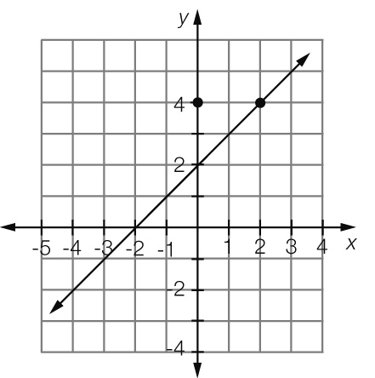

Where *x* = 2, *y* = 4

Question 5 [7.4]

A

4*x* + 4 = 3*x* + 6

4*x* − 3*x* = 6 − 4

*x* = 2

Question 6 [7.2]

A

3*b* − 5 = 4

3*b* = 4 + 5

3*b* = 9

*b* = 9 ÷ 3

*b* = 3

Question 7 [7.3]

B

3(*x* − 6) = 21

*x* − 6 = 

*x* − 6 = 7

*x* = 7 + 6

*x* = 13

Question 8 [7.4]

D

4*d* − 2 = 3*d* + 10

4*d* − 3*d* − 2 = 10

*d* = 10 + 2

*d* = 12

Question 9 [7.5]

C

5*C* + 50 = 500

5*C* = 500 − 50

5*C* = 450

*C* = 

*C* = 90

Therefore each chocolate bar costs $0.90

Multiple-choice total marks: 9

Short answer section

Question 10 1 mark [7.3]

David’s working  
 − 5 = 7  
  = 12



Question 11 1 mark [7.2]

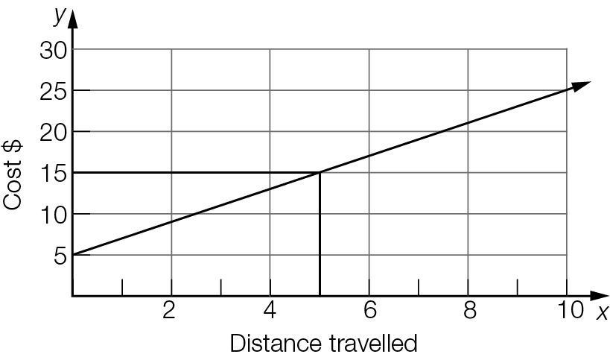

It would cost $15 to travel 5 km.

Question 12 1 mark [7.1]

2*n* = 22

Question 13 2 marks [7.1]

3*x* − 5 = 13 (*x* = 6)  
LHS = 3 × 6 − 5  
= 18 − 5   
= 13  
= RHS  
Thus *x* = 6 is a solution.

Question 14 1 mark [7.1]

*F* = *Ma*

Question 15 4 marks [7.2]

(a) *y* = 1 (b) *y* = -1

(c) *x* = -1 (d) *x* = 0

Question 16 4 marks [7.3]

(a) − 5 = 3  
= 3 + 5  
= 8  
*a* = 16

(b) = 2  
*b* + 3 = 10  
*b* = 7

Question 17 3 marks [7.2]

(a) Let the cost of a coffee be represented by the letter *c*.  
∴ 5*c* + 9 = 26.5

(b) 5*c* + 9 = 26.5  
5*c* = 26.5 – 9  
5*c* = 17.5  
*c* =   
*c* = 3.5  
Thus the cost of each cup of coffee is $3.50.

Question 18 3 marks [7.3]

3(*x* − 5) = 21  
3*x* − 15 = 21  
3*x* = 21 + 15  
3*x* = 36  
*x* =   
*x* = 12

Question 19 6 marks [7.2]

(a) 3*n* + 1 = 10  
3*n* = 10 − 1  
3*n* = 9  
*n* =    
*n* = 3  
Thus the number is 3.

(b) 2*n* − 6 = 8  
2*n* = 8 + 6  
2*n* = 14  
*n* =   
*n* = 7  
Thus the number is 7.

Question 20 2 marks [7.4]

3*x* + 8 = 5*x +* 4

8 – 4 = 5*x* – 3*x*

4 = 2*x*

*x* = 2

Question 21 3 marks [7.4]

5*x* − 4 = 4*x* + 5

5*x* − 4*x* − 4 = 5

*x* − 4 = 5

*x* = 5 + 4

*x* = 9

Question 22 3 marks [7.4]

2 − *x* = *x*

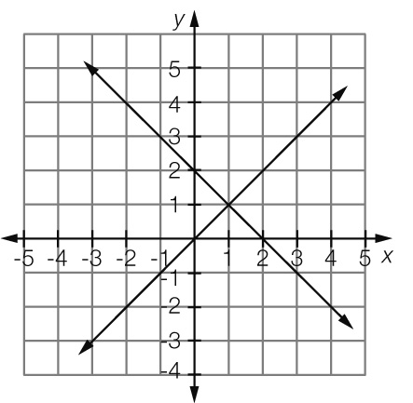

*x* = 1

Short answer total marks: 34

Extended answer section

Question 23 7 marks [7.2, 7.3, 7.5]

(a) 10 minutes

(b) Initial volume of water in the bucket is 5000 mL (at time zero).

(c) 3 minutes

(d) 3000 mL

(e) 1500 mL

(f) 5000 − 1000 = 4000 mL or 4 L

(h) *V* = 5000 − 500*t*; Dis the correct equation for the graph.

Extended answer total marks: 7

TOTAL test marks: 50